 | 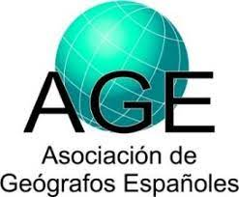 |   Commission on Local and Regional Development | 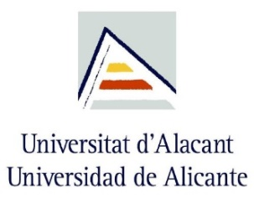

XII MEETING ON LOCAL DEVELOPMENT / I EUROPEAN MEETING ON GEOGRAPHY AND LOCAL DEVELOPMENT
“GEOGRAPHY IN THE CHALLENGES OF LOCAL DEVELOPMENT”
ALICANTE, 2024, June 3-5

ABSTRACTS
Abstracts will be written in Spanish or English, in plain text (Arial 10, titles in BOLD CAPITAL LETTERS) in this template. The structure will be:

Tittle
AUTHORSHIP; AFFILIATION; e-mail

Key themes
Mark with an x the thematic block to which the oral paper will be presented

Key themes I. Challenges of local development in professional practice
Key themes II. Challenges of local development in training
Key themes III. Challenges of local development in research

abstract
(maximum 300 words). It has to include:
(a) Context;
(b) Objectives;
(c) Design, methodology, materials, approach;
(d) Main results;
(e) Conclusions

key words
Between five and seven, whose words do not appear in the title of the abstract

Key dates
Call for abstract close | February, 10th
Notification to authors | February 20tf
Call for extended abstract close | March, 31st
Notification to authors (acceptance extended abstract) | April 29th
Registration and early fee | Until April 30th

submission of the proposal
Message subject line: Meeting Abstract
File name:
• Individual authorship: FIRST LAST_NAME_SECOND_SURNAME
• Double authorship: FIRST LAST NAME_AND_FIRST LAST NAME
• Multiple authorship: FIRST SURNAME_SECOND_SURNAME_ET_AL

SECRETARIAT OF THE CONGRESS, email <desarrollolocal@age-geografia.es>

